Chairman Mortimer Sellers
President Bill McDevitt, Esq.
Vice President Ellen Cronin
Secretary Anne M. Livingston
Treasurer Barbara Marinelli

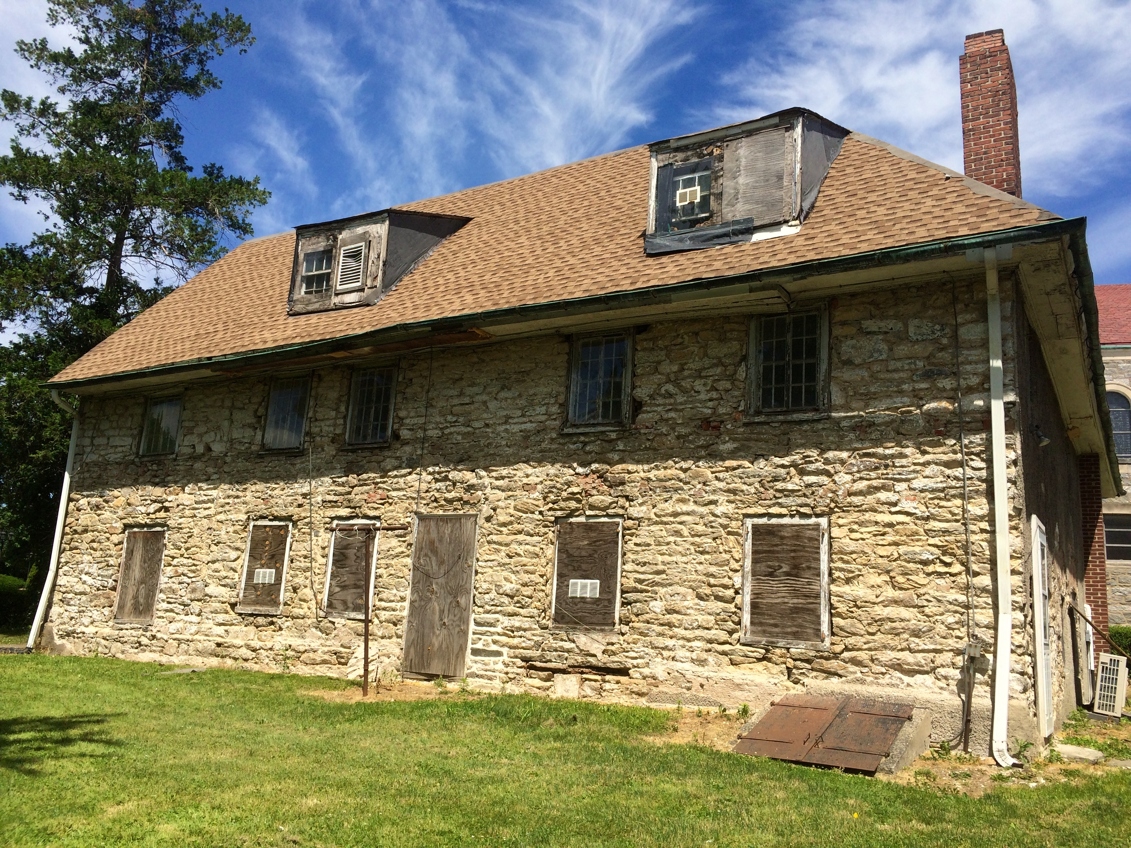

JUNE 20, 2016

Dear Friends,

Friends of Sellers Hall has achieved many accomplishments since last year’s letter.

As you can see in the picture, we removed the stucco covering of the old fieldstone on the front wall, exposing the 330-year masonry. This work revealed the placement of the original 1684 windows and other important features of the historic house. Installation of a “temporary” roof has begun, as well as new flashing on the chimneys and dormers. We will soon be installing window shutters for security. It is indeed exciting to see this work progress. Soon, we can direct our efforts toward the interior restoration. We’re looking forward to the opportunity of inviting you inside.

The Friends and the Archdiocese of Philadelphia signed an agreement of sale to purchase Sellers Hall, which will replace the long-term lease. We expect to go to settlement by the end of this month. Please check our website, www.friendsofsellershall.org for later updates.

The Township of Upper Darby has graciously awarded FOSH a Community Development Block Grant totaling $25,000 to help with our restoration. We intend to put some projects out for bid pursuant to the grant’s stipulations in order to access the money

John Milner, our historical architect, and his staff are preparing our application for a listing on the National Register of Historic Places. We have recently received a draft of the application for our review. Being listed on the National Register is an important milestone in gaining recognition and funding for more restoration.

Without you, our members, we could not have had such a successful first half of 2016. We thank you for your generous support and ask you to please consider making a special donation, in addition to your membership dues, to help FOSH move forward.

The option to donate through PayPal will be available on the website by the end of June 2016. Or you can make a contribution by mailing the form below to our treasurer.

Sincerely,
Ellen Cronin & Jessica Rutkowski

----------------------------------------------------------------------------------------------------------------------

Name ________________________________________________________
Address ______________________________________________________
City, State, Zip________________________________________________
Email _________________________________________________________
Phone ________________________________________________________
Tax deductible contribution $ _____________________________

In addition, the yearly membership dues are as listed below:
☐ Individual $30
☐ Household $40
☐ Organization $50
☐ Donor $100
☐ Patron $500 and above

Please mail to: Barbara Marinelli, FOSH Treasurer
9 Pilgrim Lane, Drexel Hill, PA 19026

